If you are exposed to Chemicals:

Immediately get in the nearest safety shower. Don't wait.
The first 15 seconds after a chemical has contacted your skin or eyes is critical.

Stay in the safety shower for a minimum of 20 minutes.

As soon as the shower starts, take off any clothing that may have been exposed to the chemical.

Ask a co-worker to call 7911 to get medical help, or use radio channel 3.
EMT's or Security will come to you.
They can bring you temporary clothing.

Hold your eyes open with your hands while using an eyewash to be sure water reaches the eyes.
Immediately wash off even small amounts of chemicals. Know the effects of chemicals with which you are working.
Read, ask questions about, and understand safety data sheets for
each chemical with which you work.

Be familiar with the locations of Emergency Shower/Eye Wash Stations in the area where you are working.

Frequently inspect and maintain the Emergency Shower/Eye Wash Stations in your area.
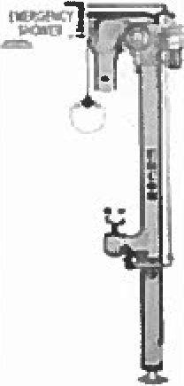

Safety Department
04/04/16

